Charlottesville redevelopment & housing Authority
P.O. BOX 1405
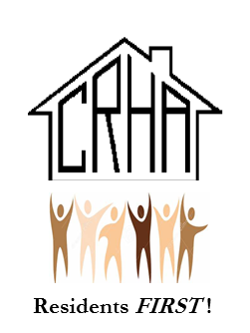
CHARLOTTESVILLE, VIRGINIA 22902

TELEPHONE/TTY/711: (434) 326-4672 FAX: (434) 971-4797

www.cvillerha.com
CRHA RESOLUTION # 1469

RESOLUTION AUTHORIZING THE SALE OF
A CERTAIN PARCELS OF PROPERTY BY THE
CHARLOTTESVILLE REDEVELOPMENT AND HOUSING AUTHORITY

WHEREAS, the Charlottesville Redevelopment and Housing Authority (the “Authority”) desires to sell certain parcels of land, with the improvements thereon, which are located in the City of Charlottesville Virginia, commonly known as 405 Avon Street and 405 Levy Avenue, Charlottesville, VA 22902 (the “Property”) to the City of Charlottesville, Virginia (the “City”); and

WHEREAS, the Authority desires to sell the Property for a sales price of $4,000,000.00 (the “Purchase Price”) to the City; and

WHEREAS, the Board has determined that it is in the best interests of the Authority, and in keeping with its mission, to sell the Property for the Purchase Price to the City.

NOW, THEREFORE, be it resolved by the Board of Commissioners of the Charlottesville Redevelopment and Housing Authority as follows:

- The sale of the Property by the Authority to the City for the Purchase Price is hereby authorized and approved.
- The Executive Director, or his designee, is hereby authorized to execute and deliver any and all contracts, agreements, deeds, instruments and other documents as may be necessary or desirable to consummate the transactions contemplated by this Resolution and to take such other action and to execute and deliver such other documents as he may deem necessary or desirable to carry out the intent of this Resolution.
- All actions heretofore taken by the Executive Director and any other officer of the Authority in connection with the transactions contemplated by this Resolution are hereby approved, adopted, ratified and confirmed in all respects.
- This Resolution shall take effect immediately upon its adoption.

RESOLVED THIS 29TH DAY OF JANUARY 2024 BY THE CRHA BOARD OF COMMISSIONERS.

Dr. Wes Bellamy
CRHA Board Chair

Mr. John M. Sales
CRHA Board Secretary

