Charlottesville redevelopment & housing Authority
P.O. BOX 1405
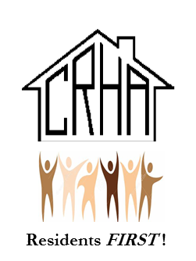
CHARLOTTESVILLE, VIRGINIA 22902

TELEPHONE/TTY/711: (434) 326-4672 FAX: (434) 971-4797

www.cvillerha.com

CRHA RESOLUTION # 1468

RESOLUTION AUTHORIZING THE PURCHASE OF
A CERTAIN PARCEL OF PROPERTY BY THE
CHARLOTTESVILLE REDEVELOPMENT AND HOUSING AUTHORITY

WHEREAS, the Charlottesville Redevelopment and Housing Authority (the “Authority”) desires to purchase a certain parcel of land, with the improvements thereon, which is located in the City of Charlottesville Virginia, identified as 0.138 acres on the south side of East Main Street and on the north side of Water Street and more commonly known as 310-312 East Main Street, Charlottesville, VA (the “Property”); and

WHEREAS, the Authority desires to acquire the Property for a purchase price of Two Million Sixty Hundred Fifty Thousand and No/100 Dollars ($2,650,000.00) (the “Purchase Price”);

WHEREAS, the Board has determined that it is in the best interests of the Authority, and in keeping with its mission, to purchase the Property for the Purchase Price.

NOW, THEREFORE, be it resolved by the Board of Commissioners of the Charlottesville Redevelopment and Housing Authority as follows:

- The purchase of the Property by the Authority is hereby authorized and approved.
- The Executive Director, or his designee, is hereby authorized to execute and deliver any and all contracts, agreements, deeds, instruments and other documents as may be necessary or desirable to consummate the transactions contemplated by this Resolution and to take such other action and to execute and deliver such other documents as he may deem necessary or desirable to carry out the intent of this Resolution.
- All actions heretofore taken by the Executive Director and any other officer of the Authority in connection with the transactions contemplated by this Resolution are hereby approved, adopted, ratified and confirmed in all respects.
- This Resolution shall take effect immediately upon its adoption.

RESOLVED THIS 29TH DAY OF JANUARY 2024 BY THE CRHA BOARD OF COMMISSIONERS.

Dr. Wes Bellamy
CRHA Board Chair

Mr. John M. Sales
CRHA Board Secretary

