Charlottesville redevelopment & housing Authority
P.O. BOX 1405

CHARLOTTESVILLE, VIRGINIA 22902

TELEPHONE/TTY/711: (434) 326-4672 FAX: (434) 971-4797

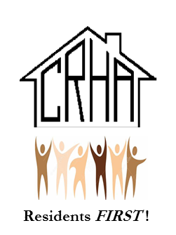
www.cvillerha.com

CRHA RESOLUTION #1465

RESOLUTION AMENDING CRHA  Camera Policy | )
 | )
)
)

WHEREAS the Board of Commissioners (the “Board”) of Charlottesville Redevelopment and Housing
Authority (“CRHA” or the “Authority”) considers the safety of CRHA residents and employees to be of
paramount importance;

WHEREAS, the Board has determined that a critical component of any effective security plan to deter
crime and protect CRHA’s communities involve the utilization of a Video Surveillance System to monitor and
record activities in public areas owned and/or managed by CRHA;

WHEREAS, in conjunction with the installation of surveillance cameras and related technology, the
Board has prepared and desires to adopt a Policy on Security Cameras and Recording of Public Areas for Safety
and Security Purposes, a copy of which is attached hereto;

WHEREAS, the CRHA Board originally adopted the camera policy on July 26, 2021;

WHEREAS, it is desired that the camera policy of the Housing Authority be more flexible to address active threats to our community;

NOW, THEREFORE BE IT RESOLVED by the Commissioners of the Charlottesville Redevelopment and Housing Authority that amendment 1 to the Camera Policy is hereby approved in all respects.

RESOLVED this twentY third day of October 2023 by the CRHA BOARD of Commissioners.

Dr. Wes Bellamy
CRHA Board Chair
Mr. John M. Sales
Board Secretary

